High-speed and High-resolution: BoxPC with V-by-One and eDP Interface

Distec Presents Robust and Low-maintenance "BoxPC Pro NPA-2009" for Info Terminals, Medical Technology and Transportation

Germering (Germany) October 11, 2022 – As one of the leading German specialists for industrial TFT flat panel displays, embedded products and system solutions, Distec GmbH introduces another innovative product: The “BoxPC Pro NPA-2009” offers a novel docking connector for direct connection of high-resolution V-by-One and/or eDP TFT displays. Areas of application for the NPA-2009 are all applications that require high-resolution displays with a high frame rate and high color depth, such as info terminals, medical technology, transportation and many more.

The trend in the TFT display sector is towards ever higher resolutions and Full HD is increasingly being replaced by 4K or 8K. The LVDS interface is not well suited for the transmission of such large amounts of data, so that high-resolution TFT displays are usually equipped with V-by-One or eDP interfaces, which have a significantly higher bandwidth. With V-by-One, the signals are transmitted at high-speed via a low-cost, standardized cable, which also has better EMC values than an LVDS cable.

Docking Connector for High-resolution TFT Displays

To enable TFT displays with V-by-One or eDP interface to be easily controlled via an SBC, Distec has developed the BoxPC Pro NPA-2009. It is based on an industrial mainboard with the Intel® Core™ i embedded processor i5-1145G7E of the 11th generation. Optionally, the NPA-2009 is also available with the Core™ i7-1185G7E or Celeron® 6305E processors on a project basis. All Tiger Lake processors feature high frame rates, economical power consumption and low latency and are suitable for continuous 24/7 operation. "A specially developed docking connector on the back of the NPA-2009 leads a V-By-One and an eDP interface to the outside, which can be used to connect and control TFT displays directly to the box PC," said Thomas Schrefel, Product Manager Embedded at Distec. "Parallel operation of 2 TFT displays - one V-by-One and one eDP - is also possible." In addition, a USB touchscreen and another USB device, such as a WebCam, can be connected via two USB 2.0 interfaces. All common V-by-One or eDP displays can thus be easily upgraded to a Panel PC, even after the fact, with the Box PC NPA-2009.

Easy Mounting and Maintenance

The BoxPC Pro NPA-2009 operates without a fan and contains no moving parts, making it very robust and low-maintenance. Captive thumbscrews make it easy to mount. A suitable DIN rail kit for control cabinet mounting is also available as an option. Distec guarantees for the NPA-2009 a long-term availability in form, fit and function of at least 5 years.

Words: 440

Keywords: Distec, BoxPC, 4k, Displays, V-by-One, eDP, Touchscreen, WebCam, USB2.0, Tiger Lake, Embedded, i5-1145G7E, Intel

Further information and data sheet:
https://www.distec.de/en/products/embedded/embedded-systems/detail/distec/boxpc-pro-npa-2009/

Images

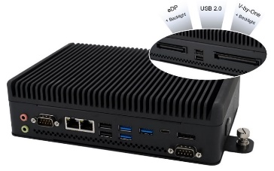 | Image 1: BoxPC Pro NPA-2009 from Distec with V-by-One and eDP interface  Image source/copyright: Distec  Download: https://www.ahlendorf-news.com/media/news/images/Distec-BoxPC-Pro-NPA2009-docking-graphics-H.jpg
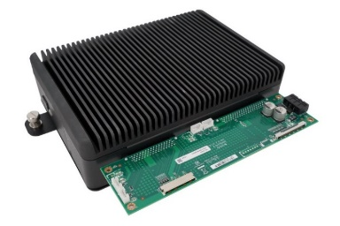 | Image 2: BoxPC Pro NPA-2009 from Distec with V-by-One and eDP interface and Docking Connector  Image source/copyright: Distec  Download: https://www.ahlendorf-news.com/media/news/images/Distec-BoxPC-Pro-NPA2009-docking-connector-H.jpg
Image 3: Thomas Schrefel is Product Manager Embedded at Distec

Image source/copyright: Distec
Download: https://www.ahlendorf-news.com/media/news/images/Distec-Thomas-Schrefel-H.jpg

About Distec

Distec GmbH is a FORTEC Group company, a globally active and recognized specialist in the field of display technology and embedded computing for projects from all industries. The company, headquartered in Germering near Munich and with a factory in Hörselberg-Hainich near Eisenach, develops, manufactures and markets innovative solutions and a wide range of components, TFT displays, embedded boards, systems and services. The innovative solutions from assemblies and kits to OEM end products are based on hardware and software developed by Distec in its own design center in Germering. Distec's range of services includes customer-specific developments and adaptations, product refinements such as VacuBond® optical bonding and the assembly of monitor systems, as well as the manufacture of finished products. A wide range of touch screens and the internal touch competence center enable individual touch solutions even for difficult environmental conditions. In addition, Distec GmbH can draw on the goods, services and know-how of the extensive FORTEC high-tech company network. Further information can be found at https://www.distec.de/

The products of Distec GmbH are available at:
Europe: Distec GmbH, Germering, https://www.distec.de/
UK and Benelux: Display Technology, Huntingdon, https://www.displaytechnology.co.uk/
North America: Apollo Display Technologies, Ronkonkoma NY, http://www.apollodisplays.com/
Turkey and Middle East: DATA DISPLAY BİLİŞİM TEKNOLOJİLERİ LTD ŞTi., Istanbul

Distec GmbH
Augsburger Straße 2b
82110 Germering
Germany
T +49 89 894363 0
F +49 89 894363 131
E distribution|at|distec.de
W www.distec.de

A company of FORTEC Group

Press contact:
Mandy Ahlendorf
ahlendorf communication
T +49 89 41109402
E ma@ahlendorf-communication.com

